Quincy Medical Center Staffing Crisis
Summary:
Throughout 2012 and early 2013 Registered Nurses have been presenting urgent pleas to Cerberus/Steward-Quincy Medical Center (QMC) management in many meetings and through written documents that they considered the declining nurse to patient staffing levels to be increasingly unsafe.
Since February 17, the situation worsened dramatically and acutely, when management shut down a 40 bed nursing unit. Since that time, RNs have been reporting staffing conditions to be so unsafe as to cause them to warn management, government agencies and the public that serious negative patient outcomes may immanently result.
On March 9, the RN members of the Massachusetts Nurses Association voted to authorize their elected committee to call a strike in protest of these conditions and management’s refusal to negotiate over staffing and related issues with them. The numbers of the vote tell their own story of how urgent RNs consider the situation to have become: 94% voted to authorize the strike. More remarkable is that 90% of the MNA members at QMC participated in the one day secret ballot vote.
The Hospital’s parent corporation, Steward Health Care, is 100% owned by the private equity giant Cerberus Capital Management, LLP. Cerberus recently came under intense criticism for its ownership of Freedom Group, the U.S.’s largest conglomerate of gun manufacturers, when it was reported in the Wall Street Journal the Boston Globe and elsewhere that they manufactured the Bushmaster AR15 style assault rifle used in the Newtown, CT massacre. Cerberus responded to the published reports and threats of divestiture from the giant California State Teachers Retirement System by announcing their intention to sell the Freedom Group.
As of this writing three months later, Cerberus remains the sole owner of Freedom Group.
Details:
Complaints of deficient staffing levels / conditions prior to February 17:
- Since January 2012, RNs at QMC have submitted to Steward management more than 150 written reports documenting what they consider to be unsafe patient care situations at the hospitals.
- In 2012, Steward reduced the total number of RNs at the hospital by 30. (There were 57 resignations. Management backfilled them by hiring only 27, and then for many months continuing through this writing have failed or refused to hire any others).
- Management’s has explicitly refused MNA’s repeated requests that it hire. The 30 position decrease was not the result of lack of applicants: For an approximate three week period in late Jan/Early Feb. when management briefly posted eight full time positions, they received more than 200 resumes, and hired no one. They subsequently rescinded the postings and announced the closure of the A3 unit.
Acutely Worsened Situation Since the February 17 Closure of the A3 Unit:
- There is no evidence that Steward management created a new staffing model to care appropriately for patients prior to the closure of the unit. In fact, hospital managers have told MNA representatives that this process began only weeks later.
- Steward management has refused to negotiate with nurses representing MNA over the staffing plan to safely care for patients or to discuss the decision to close the unit.
- Since the A3 Unit closed, frequently there have been six (6) to a high of thirteen (13) patients who have been admitted to the hospital by physicians “boarded” in the Emergency Department (ED) at a given time, sometimes for as long as 24 hours (with the longest time so far being 30 hours), waiting for an appropriate inpatient bed like those provided on the unit that was just closed.
- ED nurses report being put in the position of providing types of care for which they are not equipped to patients who have been “admitted” to the hospital as ICU, Medical Surgical or Telemetry patients, but who, in reality, are physically being housed in the ED.
- MNA members also report that they are caring for admitted patients who should not be housed there without bolstering the number of staff in the ED. Indeed, on several days the ED has been dramatically short staffed relative to staffing if there were no admitted patients boarding: There have been several episodes in the past month in which there have only been two nurses on the schedule in the Emergency Department instead of the five nurses that are supposed to be on duty to care for patients under normal circumstances. MNA RN members confronted management and asked how they expected the nurses to care for patients in the event of a “code” -- a critical case such as cardiac arrest -- which demands at least two RNs, leaving no one else to care for other crises. Management has been non-responsive, saying they aren’t obligated to have that conversation. One manager said “let’s knock on wood that that doesn’t happen.”
- Emergency Department wait times have skyrocket on many days since the closure. On Thursday, March 21, RNs reported ED wait times of five (5) hours.
- “The public needs to know how worried we are, that we’ve been telling management we don’t consider this situation to be safe, and they have been refusing to discuss the issue with us for a month,” said Stacey McEachern, RN, a nurse in the emergency department. “The patients who are being boarded in our ED have been admitted to the hospital, but are not receiving an appropriate level of care because they are being placed on stretchers in an already full emergency room, waiting for a bed on a medical floor that no longer is available to them. The bottom line is patients are being deprived of the services they need. The only explanation that Steward management has given us is that the hospital is trying to cut costs, and that their parent company Cerberus won’t invest more money.”

Facts on Several Inaccurate Public Claims Made By Cerberus-Seward:
Steward Statement: There are 20 posted Outpatient RN positions. Steward PR representative Chris Murphy has repeated this statement to the Boston Globe (“He said the hospital has 20 nurses vacancies in outpatient units and that laid-off nurses can apply for those jobs if they have the experience,” and the Patriot Ledger).
Facts: Patently false. Steward-Quincy Medical Center has posted zero (0) outpatient RN positions. Print out available upon request.
Additionally: Quoting from the Boston Globe 3/18/2013: “While the move has prompted outcry from employees, Steward spokesperson Christopher Murphy said that the focus from inpatient care to outpatient services has not and will not affect the patients negatively. ‘There is no lack of inpatient resources,’ Murphy said. ‘Despite any resource change from inpatient to outpatient, QMC maintains more than enough inpatient beds to meet the current volume and to meet a volume to grow.’ Murphy confirm the changed in direction but declined to specifically confirm that the surgical unit was closing. He also declined to say how many jobs may be lost due to the shift.” All aspects of his statement are misleading and unsubstantiated. There is no current transition from inpatient to commensurate outpatient services. To the extent that there was such a transition, it took place several years ago.
Steward Statement: QMC CEO Daniel Knell objected to the term “layoff,” in a March 23 Patriot Ledger article: “We’d rather say we have flexed down,”
Fact: Quoting the layoff letter to RNs of March 18: “Dear____, Your employment with Steward Health Care System LLC will end at the conclusion of your regularly scheduled shift or work day on April 12, 2013.”
Steward Statement: In several articles Steward PR representative Chris Murphy has said that ER wait times are 25 minutes.
Fact: Patently false. A) At issue is the period since February 17, 2013, when Steward’s decision to shutter the 40 bed A3 unit created a crisis. In that period wait times on many days have risen into the several hours. EG five (5) hour wait time Thursday, 3/21. B) ER wait times prior to this crisis were actually much higher than Murphy states (documentation available upon request).
Steward Statement: A recent decision to open the 14 bed “A2” unit will handle the overflow created by the closure of the 40 bed A3 unit.
Fact: Patently false. Most days that unit is closed. Shut. An example: On March 15 in a meeting with MNA Steward’s QMC Chief Nursing Office said in presence of Steward’s management team the MNA Committee that A2 would now be open “27/7. That means 24 hours a day seven days a week,” and would be staffed for 14 beds.
- Management immediately refused to commit to this in writing.
- Management refused to discuss the nurse to staff ratios on the unit.
- After a break managers returned to say only 10 beds will be open, but repeated that it will be open “24/7 and it is open right now and will remain open.”
- This meeting ended at 6:05 pm on 3/15, and then management completely shut down the A2 unit at 8pm. It remained shut down for the next two days. We later learned that it was being shut down and patients were being moved out of it while Steward managers were telling us that it was now open “24/7.” Subsequently it has been partially opened and then entirely shut down again several times.
Steward Statement: Cerberus-Steward has made capital investments in this and other hospitals.
Facts: According to reports in CommonWealth Magazine, Cerberus hasn’t invested capital in the hospitals so much as they have provided a line of credit for Steward and the hospitals themselves to take on debt themselves to finance capital projects. This appears to be confirmed by Steward’s 2011 audited financial statement. While Steward points to an operating loss at QMC, the CommonWealth report and the audited financials also point to more than $8 in management fees paid to Cerberus in the most recent fiscal year reported. They also point to financial penalties Steward and its hospitals would pay to Cerberus if they do not make full use of the offered line of credit.
Steward Statement: Steward QMC CEO Daniel Knell published an insulting letter in response to the unsafe patient care concerns raised by staff, in which he said that full time RNs at QMC make “$120,000 a year.”
Fact: Patently false. The average QMC RN grosses about a third of this number in a year. Many RNs have sent photocopies of their paystubs to Knell with joking request that he issue a correction check, “Now that I know that I received this in error.” His hostile response had nothing to do with the concerns over management’s refusal to bargain over unsafe staffing levels and fears for patient safety that prompted MNA members to vote to authorize a strike
Steward Statement: Steward QMC advertises very specific RN staffing numbers for each of its inpatient units on the Patient Care Link web site.
Fact: MNA has evidence that these published numbers are false, that Steward is aware that they are false, and bear no connection to reality:
In a meeting with Steward-QMC management on 3/15, MNA representatives asked whether Steward management would be willing to commit to the staffing plans / numbers by unit which Steward-Quincy Medical Center advertizes on the Mass Hospital Association / Patient Care Link web site. The hospital’s Chief Nursing Officer said this was the first time she was hearing that QMC publishes staffing numbers by unit, and that she “never provided any such information to anyone,” and “can’t imagine where any such numbers would come from.” Steward-QMC’s Human Resources Director then said that she was the only other person who would have access to that data and she has “never provided it to anyone,” and she has never heard that numbers were on any web site, and that she “can’t imagine where such numbers come from.” Steward’s Assistant General Counsel and several other members of the Steward and QMC management team were present. (Screen prints of the MHA / Patient Care Link web pages for Quincy Medical Center made on 3/17/2013 are attached).

Screen prints of Steward’s advertised staffing patterns at QMC (which appear to be falsified data with no connection to reality):
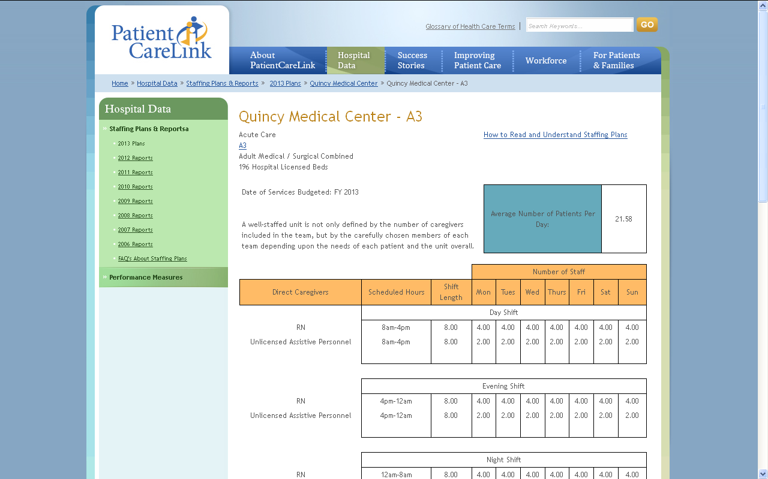
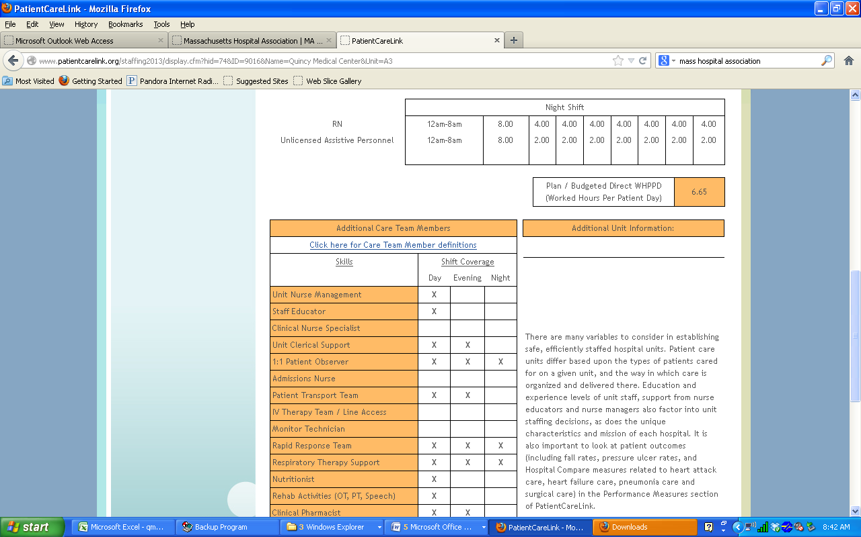
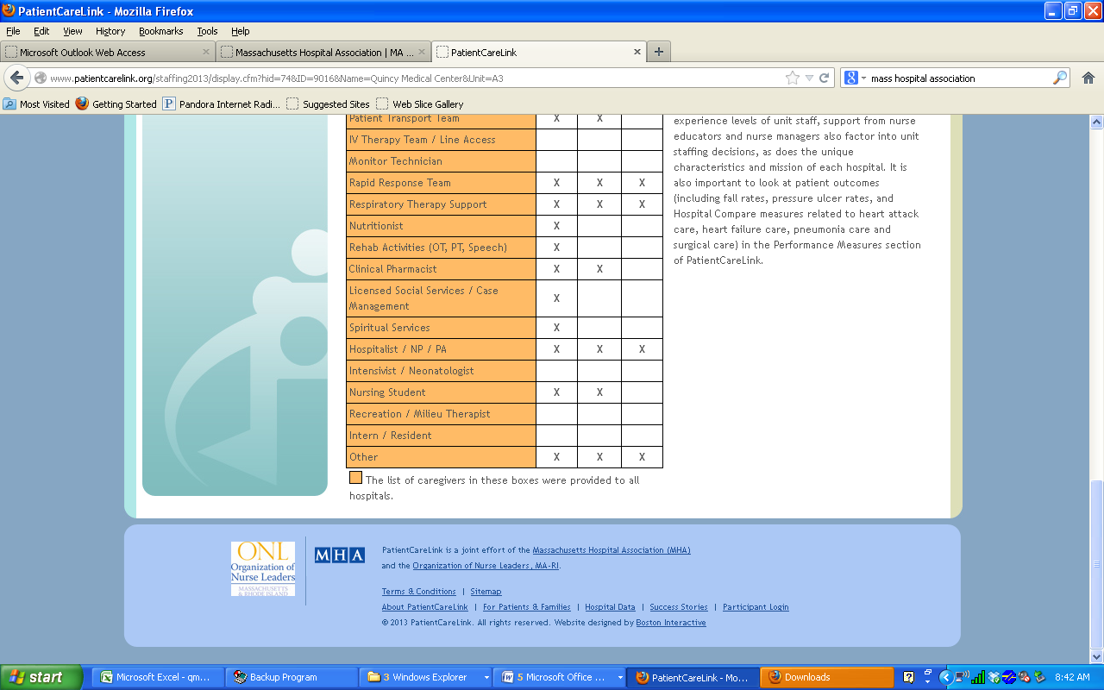

Quincy Medical Center Nurses Cast Overwhelming Vote (94 %) to Strike Over Staffing Conditions
Vote Follows Decision by Cerberus-Steward to Close and Refuse to Negotiate over a
40-Bed Medical/ Surgical Unit, Resulting in Patients Being Boarded in the Hospital Emergency Department For Up to 24 Hours Without Appropriate Care
Nurses file unfair labor practice charge against Steward with the National Labor Relations Board for refusing to negotiate over a staffing plan that would ensure the safety
of the patients under the nurses' care.
QUINCY, Mass., March 19, 2013 /PRNewswire-USNewswire/ -- Nurses at Quincy Medical Center cast an overwhelming vote last night to authorize a one-day strike over dangerous staffing conditions at their hospital and a recent decision by Cerberus-Steward, the for-profit owner of the hospital, to close a 40-bed medical-surgical unit and layoff 30 nurses and more than 40 other health care staff who provide care to patients admitted to the hospital.
The secret ballot vote was held throughout the day yesterday at Quincy Medical Center. The nurses voted 200 to 13 (94 percent) in favor of a strike, with a 90 percent voter turnout. The vote gives authority to the RNs' elected bargaining committee to schedule a strike. If and when that decision is made, the hospital will have at least 10 days notice before the strike can occur.
As a result of the closure, which was initiated on February 17, 2013, nurses report that as many as a dozen patients per day are being "boarded" in the hospital's emergency department (ED), sometimes for as long as 24 hours (or more), waiting for an appropriate inpatient bed like those provided on the unit that was just closed. ED nurses report being put in the position of providing types of care for which they are not equipped for patients who have been "admitted" to the hospital as ICU, Medical Surgical or Telemetry patients, but who, in reality, are physically being housed in the ED. They also report that they are caring for admitted patients without bolstering the number of staff in the ED. When not boarded in the emergency department, patients are being shuffled to other areas of the hospital, such as the intensive care unit, which means that there are now fewer beds available for more critically ill patients. Massachusetts Nurses Association/National Nurses United nurses have been complaining urgently to Steward management for four weeks that patients are not receiving the level of nursing care they should expect and deserve, and that they are greatly concerned about immanent potentially negative outcomes.
"The public needs to know how worried we are, that we've been telling management we don't consider this situation to be safe, and they have been refusing to discuss the issue with us for a month," said Stacey McEachern, RN , a nurse in the emergency department. "The patients who are being boarded in our ED have been admitted to the hospital, but are not receiving an appropriate level of care because they are being placed on stretchers in an already full emergency room, waiting for a bed on a medical floor that no longer is available to them. The bottom line is patients are being deprived of the services they need. The only explanation that Steward management has given us is that the hospital is trying to cut costs, and that their parent company Cerberus won't invest more money."
The nurses have been attempting for months, well before the closing of the unit, to convince the hospital to negotiate with them to improve staffing levels. In the past 12 months, nurses have filed more than 150 written reports of unsafe conditions at the hospital where they felt the safety of their patients was placed in jeopardy. In early January, dozens of nurses from the hospital, including nurses from the unit that was just closed, were out in the community, handing out leaflets at T stations and shopping centers detailing their serious concerns about potentially unsafe staffing conditions at the hospital. Last Friday, nurses filed a report with the Department of Public Health, citing unsafe patient care conditions.
There have been several episodes in the past month in which there have only been two nurses on the schedule in the Emergency Department instead of the five nurses that are supposed to be on duty to care for patients under normal circumstances. McEachern and the MNA/NNU confronted management and asked how they expected the nurses to care for patients in the event of a "code" -- a critical case that demands at least two RNs, leaving no one else to care for other emergencies. Management has been non-responsive, saying they aren't obligated to have that conversation.
"At a time when we already lacked the staff needed to provide the care our patients deserve, Steward has inflamed the situation by closing a unit that we desperately need," said Paula Ryan, RN , a nurse at the hospital and chair of the MNA local bargaining unit. "What is worse, they made this decision without fulfilling their obligation to meet with us and to ensure we had a staffing plan in place to ensure the safety of our patients." The MNA/NNU is filing an unfair labor practice charge against the hospital with the National Labor Relations Board over management's refusal to negotiate over these and related issues.
"Our members have had enough," said Ryan. "We have attempted to negotiate for months with management. We have presented official reports; we have told them we are worried that there are immanent risks of negative patient outcomes. They have refused to respond except to say that this is a financial decision. We feel that we have a duty to our patients and our practice and to each other to take action. The final straw was last Friday: We met with management, they refused to bargain. They told us 10 beds in a small ancillary unit would be open '24 hours a day and seven days a week' from now on to relieve some of the pressure. But they refused to commit to that or anything else in writing. Two hours later they closed that unit and it remained closed all weekend."
The 235 nurses at Quincy Medical Center have been in negotiations for their first contract with Cerberus Steward, which purchased the hospital in October of 2011. Countless negotiations sessions have been held since December 2011.
Founded in 1903, the Massachusetts Nurses Association is the largest professional health care organization and the largest union of registered nurses in the Commonwealth of Massachusetts. Its 23,000 members advance the nursing profession by fostering high standards of nursing practice, promoting the economic and general welfare of nurses in the workplace, projecting a positive and realistic view of nursing, and by lobbying the Legislature and regulatory agencies on health care issues affecting nurses and the public. The MNA is also a founding member of National Nurses United, the largest national nurses union in the United States with more than 170,000 members from coast to coast.
SOURCE Massachusetts Nurses Association/National Nurses United

Endnotes:

Boston Globe, 3/19/2013: Nurses union authorizes one-day strike at Quincy Medical Center after hospital closes medical surgical unit and lays off 30 nurses: http://www.boston.com/whitecoatnotes/2013/03/19/nurses-quincy-medical-center-planning-one-day-strike/TNQ9vVibdofpxuEMdmifDO/story.html And: MNA press statement 3/18/2013: http://www.prnewswire.com/news-releases/quincy-medical-center-nurses-cast-overwhelming-vote-94--to-strike-over-staffing-conditions-198986431.html And: http://www.bostonglobe.com/business/2013/03/19/nurses-union-authorizes-one-day-strike-quincy-medical-center-after-hospital-closes-medical-surgical-unit-and-lays-off-nurses/Vq8SWF0ZhpItqf7aSKxWVL/story.html
http://www.cerberuscapital.com/
Boston Globe: “Steward Health Care Parent Company Owns Gun Firm”: http://www.bostonglobe.com/business/2012/12/18/cerberus-capital-owner-steward-health-care-boston-also-owns-maker-bushmaster-rifle-used-newtown-shootings/87mKS2CJNcr2grFPAJMVTK/story.html
Wall Street Journal, Calstrs Reviewing Cerberus Investment in Light of Newtown Shooting http://blogs.wsj.com/deals/2012/12/17/calstrs-reviewing-cerberus-investment-in-light-of-newtown-shooting/ and http://online.wsj.com/article/SB10001424127887324907204578187623794707396.html?mod=djemITP_h
Huffington Post: http://www.huffingtonpost.com/2012/12/18/cerberus-capital-freedom-group-gun-manufacturer_n_2321258.html ). See Also: New York Times Op Ed: http://www.nytimes.com/2013/01/19/opinion/nocera-investing-in-guns.html?ref=cerberuscapitalmanagement&_r=0 ).
Boston Globe: 3/19/2013 http://www.bostonglobe.com/business/2013/03/19/nurses-union-authorizes-one-day-strike-quincy-medical-center-after-hospital-closes-medical-surgical-unit-and-lays-off-nurses/Vq8SWF0ZhpItqf7aSKxWVL/story.html
Boston Globe, 3/18/2013, “Plans to Close Quincy Medical Center Surgical Unit Spark Protest.” http://www.boston.com/yourtown/news/quincy/2013/03/plans_to_close_quincy_medical.html
Patriot Ledger 3/23/2013, http://www.patriotledger.com/news/x1893343409/Cuts-capital-improvements-for-Quincy-Medical-Center
CommonWealth Magazine, September, 2012: http://www.commonwealthmagazine.org/Voices/Back-Story/2012/Summer/010-Stewards-finances.aspx
Steward 2011 Audited Financial statement: http://www.commonwealthmagazine.org/Programs/Full-Disclosure/~/media/Files/Commonwealth%20Magazine/Misc%20Docs/Steward%20St%20%20Elizabeth%20FS.ashx
http://www.patientcarelink.org/staffing2013/units.cfm?ID=74&Name=Quincy%20Medical%20Center. Screen prints made on 3/17/2013 are also appended to this document.

